

**MIS605 Systems Analysis and Design**

**Assessment 1**

**Student name: Bharti**

**Student id:**

**Introduction**

The Healthy Collective is an Australian health and wellness member organization committed to building a healthy community by providing accessible and transparent healthcare options. To enhance their services and customer experience, they seek a user-friendly and customizable CRM solution. The proposed CRM should support customer profiling, marketing campaigns, reporting, customer support services, document management, contract tracking, and contact sharing. Furthermore, the organization wants a flexible and upgradable CRM system to meet its future needs as they evolve. CRM system is used to develop a customer relationship management system which is designed to make customer interaction easy with the application. This report also defines all the necessary needs to build a CRM system. It includes an SDLC model, project life cycle, identification of actors (i.e. human and non-human), use case diagram, and an elaborated version of all the important use case procedures.

# Question 1

## Selected SDLC model

The selected SDLC model for the development of The Healthy Collective model is the Agile model.

The Agile Software Development Life Cycle is best suited for this project, based on the case study this software needs an iterative and incremental process model which helps in making good software which meets all the requirements. By implementing Agile SDLC the model always focuses on continuous improvements, flexibility, and customer satisfaction which are best suited to the objectives of The Healthy Collective. It also allows for frequent testing and feedback, which is the main requirement in a CRM system for constant improvement.

The project life cycle is divided into five phases:

1. **Operate and maintain the system:** In this phase, the goals and objectives of the project is being defined, all the required resources are allocated for the development process, and the required team member opts.
2. **Analyse User requirements:** In this phase,all the requirements for the CRM system are defined, and the feasibility of the project is evaluated.
3. **Design the Program:** In this phase, the architecture is designed, and the system’s components are identified.
4. **Code the Program:** In this phase, the designed architecture is developed and tested for various test cases.
5. **Document and test the System:** In this phase, the project is being deployed with ongoing maintenance and support to ensure the system’s stability and performance.

Figure 1: Agile SDLC model

The Agile SDLC model was chosen for this project because it allows for flexibility and frequent feedback, essential for a CRM system requiring continuous refinement. The project life cycle phases were chosen to ensure that the project is well planned, analysed, designed, implemented, and maintained to meet The Healthy Collective's objectives of building a customer-centric and user-friendly CRM system.

## Project life cycle

There are total 5 stages for the project life cycle:

Figure 2: project life cycle

* **Initiation:** This phase is the initial stage of the project life cycle which includes the planning and preparation of the project. The project sponsor, Nick T will identify the need for a CRM system and prepare a project charter which helps to outline the project’s scope, timeline, budget, and stakeholders.
* **Planning:** In this stage, all the required planning for the development and deployment of the project in detail has been designed. Also at this stage, all the potential risks are identified and develop a risk management plan to reduce the risks.
* **Execution:** At this stage, all the planning for the CRM system are get implemented. Develop the required customizations, and perform any necessary data migrations from the existing system.
* **Monitoring and Controlling:** At this stage, it involves monitoring and control of the project to ensure that the project is on track and within the budget. This phase/stage will continue until the project is completed.
* **Closure:** This phase involves the finalization and handover of the CRM system to The Healthy Collective. In this phase, the project team will perform a final review of the system, ensure all documentation is complete, and conduct a formal handover to the end users and administrators.

**Question 2**

## Human Actors

* **Nick T (Managing Director of the Healthy Collective)** – primary actor, who requires a CRM solution for The Healthy Collective.
* **Customers** – primary actors, who are divided into three sub-groups:
  + - End-users
    - Practitioners
    - Business/organizations
* **Healthy Collective employees –** secondary actors,who will use the CRM solution to manage customer relationships and support services.

## Non-Human Actors

* **HubSpot CRM -** an abstract actor, which is already being implemented by HC for CRM purposes.
* **Admin Portal -** an abstract actor, which allows the creation of new roles and access to various functionalities in the CRM system.
* **Marketing Campaigns -** abstract actors, which will be managed through the CRM solution and will involve various marketing features.
* **Workflow Management -** an abstract actor, which will allow the creation of workflows involving stakeholders and will ensure traceability of work.
* **Customer Support Service -** an abstract actor, which will be managed through the CRM solution and will involve customisable mechanisms for customer support.
* **Document Management -** an abstract actor, which will be managed through the CRM solution and will involve tracking, sharing, and maintaining the configuration of shared documents.
* **Proposal Tracking -** an abstract actor, which will be managed through the CRM solution and will involve tracking proposals.

**Question 3**

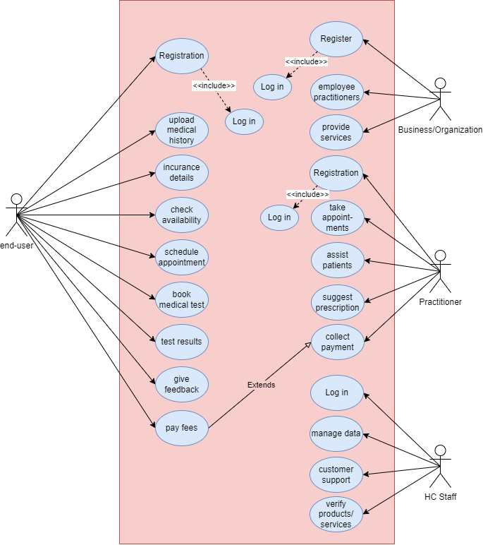

Figure 3: use case diagram

**Question 4**

|  |  |
| --- | --- |
| Use Case No. | U1 |
| Case Type | Base |
| Name | User Registration |
| Actors | End-Users/Practitioners/Businesses or Organizations |
| Associated Data Source | The sources associated are member registration forms for every new registration. |
| User Interface | The user interfaces or screen that is associated with this particular case is the Individual Registration screen which is a web interface for the End-User, Practitioners, Businesses, and Organizations a dedicated form collects important information for registration. |
| Preconditions | * The user must have access to the internet and the web interface of the CRM system. * The practitioners and businesses/organizations decide mutually to work with each other. |
| Post-conditions | * Registration is the main process of accessing the website; after registration, the user can access the CRM system products/services provided by the businesses/organizations. * In the case of practitioners and businesses/organizations, after registration they can access the CRM system and assign roles. |
| Description of the case | The user wants to register for the CRM system to access its functionalities. The user enters their details, including name, contact details, and login credentials. The system validates the input and creates a new user account with the appropriate roles. |
| Flow chart depicting the normal flow |  |
| Alternate course(s) | If the input validation fails, the system displays an error message and prompts the user to correct their input. |

|  |  |
| --- | --- |
| Use Case No. | U2 |
| Case Type | Base |
| Name | Customer profiling |
| Actors | End-Users/Practitioners/Businesses or Organizations |
| Associated Data Source | The sources associated are members’ user input during the registration process based on which their profile will get created. |
| User Interface | The user interfaces or screen that is associated with this particular case is the Individual who provides user inputs on the web interface for the End-User, Practitioners, Businesses, and Organizations. |
| Preconditions | * The user must have access to the internet and the web interface of the CRM system. * The user must have access to the CRM system and have the appropriate roles assigned. |
| Post-conditions | * After successful login to their accounts the customers can make changes accordingly in their profile section. * The user’s profile is been updated with the newly provided information. |
| Description of the case | The user wants to update their profile with new information. The user enters the new data into the dynamic form, which populates their customer profile. The system updates the customer profile with new information. |
| Flow chart depicting the normal flow |  |
| Alternate course(s) | If the input validation fails, the system displays an error message and prompts the user to correct their input. |

|  |  |
| --- | --- |
| Use Case No. | U3 |
| Case Type | Base |
| Name | Service Request |
| Actors | End-Users |
| Associated Data Source | The sources associated are members’ user input on the service page while requesting the services. |
| User Interface | The user interfaces or screen that is associated with this particular case is the service page, on which the user has to select the desired service and provide the necessary information for making a request. |
| Preconditions | * The user must have access to the internet and the web interface of the CRM system. * The user must be verified with the login credentials. * The user must have access to the CRM system and have The Healthy Collective’s services. |
| Post-conditions | * After successful registration for the desired service. * The new service request was created and assigned to the appropriate personnel. * When service is accepted, a confirmation message is received. |
| Description of the case | The user wants to request a new service from the organization. The user navigates to the service request page and enters the required information, including the service type, description, and priority level. The system creates a new service request and assigns it to the appropriate personnel based on their role and availability. |
| Flow chart depicting the normal flow |  |
| Alternate course(s) | If the input validation fails, the system displays an error message and prompts the user to correct their input. |

|  |  |
| --- | --- |
| Use Case No. | U3.1 |
| Case Type | Base |
| Name | Service Request Tracking |
| Actors | End-Users |
| Associated Data Source | The sources associated are members’ user input for the registered service. To track the service request they have to provide a service ID. |
| User Interface | The user interfaces or screen that is associated with this particular case is the service track page, on which the user has to insert a valid service ID to get updates on it. |
| Preconditions | * The user must have access to the internet and the web interface of the CRM system. * The user must be verified with the login credentials. * The user must have access to the generated service request ID. |
| Post-conditions | * After inserting the service request ID, a page is displayed that confirms the service request status. * After successfully assigning to the appropriate personnel, this page displays the status along with the name of the assigned personnel. |
| Description of the case | The user wants to track the status of their service request. The user navigates to the service request tracking page and enters their service request ID. The system retrieves the status of the service request and displays it to the user |
| Flow chart depicting the normal flow |  |
| Alternate course(s) | If the input validation fails, the system displays an error message and prompts the user to correct their input. |

|  |  |
| --- | --- |
| Use Case No. | U4 |
| Case Type | Base |
| Name | Service Request Resolution |
| Actors | Practitioner |
| Associated Data Source | The sources associated are the received service request data and members’ user input to retrieve request information. |
| User Interface | The user interfaces or screen that is associated with this particular case is the service request resolution page on the practitioner dashboard, which can be accessed through the web interface. |
| Preconditions | * The Practitioner must have access to the internet and the web interface of the CRM system. * The Practitioner must be verified with the login credentials. * The practitioner must have access to the generated service request data. |
| Post-conditions | * After accepting the pending request or performing the request, the request status gets updated and marked as resolved. * After the service request is marked as resolved, the end-user is notified of the same. |
| Description of the case | The practitioner receives the assigned service request and begins working on it. Once the service request is completed, the practitioner marks it as resolved in the CRM system. The system updates the service request status, and the end user gets notified of the resolution. |
| Flow chart depicting the normal flow |  |
| Alternate course(s) | If the input validation fails, the system displays an error message and prompts the user to correct their input. |

|  |  |
| --- | --- |
| Use Case No. | U5 |
| Case Type | Base |
| Name | Service Feedback |
| Actors | End-User |
| Associated Data Source | The sources associated are the end-user can upload feedback about the experience of the requested service along with their service request ID. |
| User Interface | The user interfaces or screen that is associated with this particular case is the feedback option associated with the service page from where end-user can upload their feedback on the particular service. |
| Preconditions | * The end-user must have access to the CRM system, along with the service request ID. * To send the feedback the requested service should have been marked as resolved. |
| Post-conditions | * After the requested service has been marked as resolved, the end user can upload the feedback based on their experience. * The end user’s feedback is recorded in the CRM system, which can be seen by the assigned practitioner and business/organization. |
| Description of the case | The End-User wants to provide feedback on the service they received. The user navigates to the service status page from there navigates to the feedback option and enters their comments/feedback/experience. The system records the feedback in the CRM system for future analysis. |
| Flow chart depicting the normal flow |  |
| Alternate course(s) | If the input validation fails, the system displays an error message and prompts the user to correct their input. |

|  |  |
| --- | --- |
| Use Case No. | U6 |
| Case Type | Base |
| Name | Customer feedback analysis |
| Actors | HC staff |
| Associated Data Source | The sources associated are the database from which HC staff gets all the required information about the application. In this case, they retrieve feedback records from the database. |
| User Interface | The user interfaces or screen that is associated with this particular case is web-based, the HC staff have the access to the admin portal of the application from which all the required information about the application can be gathered. |
| Preconditions | * The HC staff members must have access to the CRM system’s admin page. * Appropriate personnel only have the access to feedback analysis in the CRM system. |
| Post-conditions | * The HC staff has analysed the CRM data and identified the areas for improvement based on the received feedback. |
| Description of the case | The HC staff member wants to analyse the CRM data to identify areas for improvement in the organization's customer service. The HC staff member navigates to the analysis page and selects the relevant data sets to analyse. The system generates visualizations and reports to help the analyst identify areas for improvement. |
| Flow chart depicting the normal flow |  |
| Alternate course(s) | If the HC staff member encounters any issues in analysing the data, they can seek assistance from higher authorities or technical support. |